Programming Lab 10 - Documentation
- Problem Statement
Write a program to create a random access file of 100 records named “credit.dat”. Then create and use write, read and print functions to manipulate the client data. There will be a struct used called clientData (which stores the accountNumber, lastName, firstName, and account balance).

- Requirements
  - Assumptions
- Input set through user input
- Output will be handled by the command line

  - Specifications
- struct clientData
  - Account Number of client file
  - Last Name of client
  - First Name of client
  - Balance of client file
- printClientData
  - print out information about client (first and last name), account, and balance
- writeFile
  - user enters an account number (between 1 and 100, 0 to end input), and it asks about what to input, and then write it into the account number’s section
- readFile
  - user enters an account number (between 1 and 100, 0 to end input), and it prints out all the data fields
- printFile
  - does the mandatory checks before calling the printClientData function to print data

- Decomposition Diagram
- Program:
  - Input
    - Program takes inputs from program and user input
  - Process
    - Functions listed will be called and used to manipulate data
  - Output
    - Program will print out the results onto the command line via usage of the print function

Struct clientData
Responsibilities:  +accountNumber: int  +lastName:char  +firstName:char  +balance:float | Collaborators: NA

- Test Strategy
- Valid Test
- Invalid Test

- Test Plan Version 1
Test Strategy | Test Number | Description | Input | Expected Output | Actual Output | Pass/Fail
Valid Test | 1 | Make account 1
Valid Test | 2 | Make account 2
Valid Test | 3 | Read/print account 1
Valid Test | 4 | Read/print account 2
Invalid Test | 5 | Input non-integer for balance

- Initial Algorithm
- struct clientData
  - Account Number of client file
  - Last Name of client
  - First Name of client
  - Balance of client file
- printClientData
  - print out information about client (first and last name), account, and balance
- createFile
  - create a blank client file and initialize the data
- writeFile
  - user enters an account number (between 1 and 100, 0 to end input), and it asks about what to input, and then write it into the account number’s section
- readFile
  - user enters an account number (between 1 and 100, 0 to end input), and it prints out all the data fields
- printFile
  - does the mandatory checks before calling the printClientData function to print data

- Test Plan Version 2

Test Strategy | Test Number | Description | Input | Expected Output | Actual Output | Pass/Fail
Valid Test | 1 | Make/Read/Print account 1 | 1  Simhan  Srinivas  100 | Client data for account number: 1  Last name: Simhan  First name: Srinivas  Balance: 100
Valid Test | 2 | Make/Read/Print account 2 | 2  Wohl  Jordan  50 | Client data for account number: 1  Last name: Wohl  First name: Jordan  Balance: 50
Valid Test | 3 | Make/Read/Print account 3 | 3  Hicks  Darrius  313 | Client data for account number: 3  Last name: Hicks  First name: Darrius  Balance: 313
Valid Test | 4 | Make/Read/Print account 4 | 4  Steiner  Thomas  1000 | Client data for account number: 4  Last name: Steiner  First name: Thomas  Balance: 1000
Invalid Test | 5 | Input non-integer for balance | 5  A  G  A | *ERROR*

- Code
#include <iostream>
#include <fstream>
#include <cstring>
using namespace std;

struct clientData
{
int accountNumber;
char lastName[15];
char firstName[10];
float balance;
};

void printClientData(clientData c)
{
cout << "Client data for account number: " << c.accountNumber << endl;
cout << "\tLast name: " << c.lastName << endl;
cout << "\tFirst name: " << c.firstName << endl;
cout << "\tBalance: " << c.balance << endl << endl;
}

void createFile()
{
ofstream outCredit("credit.dat", ios::out);
clientData blankClient = { 0,"","",0.0 };

for (int i = 0; i < 100; i++)
{
outCredit.write(reinterpret_cast<const char*>(&blankClient), sizeof(clientData));
}
}

void writeFile()
{
ofstream outCredit1("credit.dat", ios::ate); // access anywhere
int userAccountNumber = -1;
while (userAccountNumber != 0) {
cout << "Enter an account number (1-100, 0 to stop): ";
cin >> userAccountNumber;
if (userAccountNumber <= 100 && userAccountNumber >= 1) {
clientData client;
client.accountNumber = userAccountNumber;
cout << "Enter last name: ";
char lastname[15];
cin >> lastname;
memcpy(client.lastName, lastname, 15 * sizeof(char));
cout << "Enter first name: ";
char firstname[10];
cin >> firstname;
memcpy(client.firstName, firstname, 10 * sizeof(char));
cout << "Enter balance: ";
float balance;
cin >> balance;
client.balance = balance;

outCredit1.seekp((client.accountNumber - 1) * sizeof(clientData));
outCredit1.write(reinterpret_cast<const char*>(&client), sizeof(clientData));
}
}
}

void readFile(ifstream& inCredit)
{
clientData client;
int userAccountNumber = -1;
while (userAccountNumber != 0) {
cout << "Enter account number (1-100, 0 to stop): ";
cin >> userAccountNumber;
if (userAccountNumber >= 1 && userAccountNumber <= 100)
{
inCredit.seekg((userAccountNumber - 1) * sizeof(clientData));
inCredit.read(reinterpret_cast<char*>(&client), sizeof(clientData));
printClientData(client);
}
}
}

void printFile(ifstream& inCredit)
{
clientData client;
inCredit.read(reinterpret_cast<char*>(&client), sizeof(clientData));
while (inCredit && !inCredit.eof())
{
if (client.accountNumber != 0)
{
printClientData(client);
}
inCredit.read(reinterpret_cast<char *>(&client), sizeof(clientData));
}
}

int main()
{
createFile();
writeFile();
ifstream inCredit("credit.dat", ios::in);
readFile(inCredit);
printFile(inCredit);
return 0;
}

- Updated Algorithm
- struct clientData
  - Account Number of client file
  - Last Name of client
  - First Name of client
  - Balance of client file
- printClientData
  - print out information about client (first and last name), account, and balance
- createFile
  - create a blank client file and initialize the data
  - data is initialized for all positions from 0 to 100
- writeFile
  - user enters an account number (between 1 and 100, 0 to end input), and it asks about what to input, and then write it into the account number’s section
  - enter last name, enter first name, and enter balance
- readFile
  - user enters an account number (between 1 and 100, 0 to end input), and it prints out all the data fields
  - if the account number is between 1 and 100, then it will seek and read the client information associated with that account number
- printFile
  - does the mandatory checks before calling the printClientData function to print data
- main
  - call createFile
  - call writeFile
  - ifstream and input into a data file
  - call readFile
  - call printFile

- Test Plan Version 3
Test Strategy | Test Number | Description | Input | Expected Output | Actual Output | Pass/Fail
Valid Test | 1 | Make/Read/Print account 1 | 1  Simhan  Srinivas  100 | Client data for account number: 1  Last name: Simhan  First name: Srinivas  Balance: 100 | *see screenshot 1* | Pass
Valid Test | 2 | Make/Read/Print account 2 | 2  Wohl  Jordan  50 | Client data for account number: 1  Last name: Wohl  First name: Jordan  Balance: 50 | *see screenshot 1* | Pass
Valid Test | 3 | Make/Read/Print account 3 | 3  Hicks  Darrius  313 | Client data for account number: 3  Last name: Hicks  First name: Darrius  Balance: 313 | *see screenshot 1* | Pass
Valid Test | 4 | Make/Read/Print account 4 | 4  Steiner  Thomas  1000 | Client data for account number: 4  Last name: Steiner  First name: Thomas  Balance: 1000 | *see screenshot 1* | Pass
Invalid Test | 5 | Input non-integer for balance | 5  A  G  A | *ERROR* | *see screenshot 2* | Pass

- Screenshots
Screenshot 1:
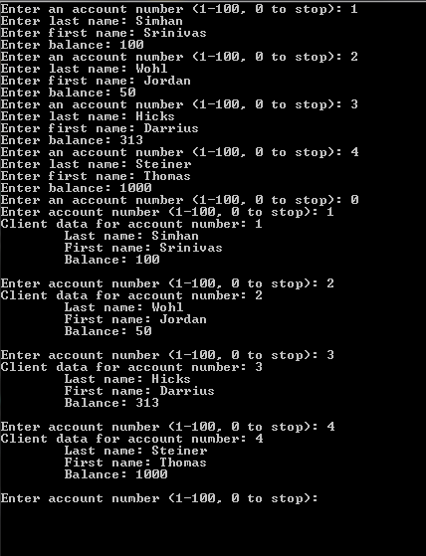

Screenshot 2:
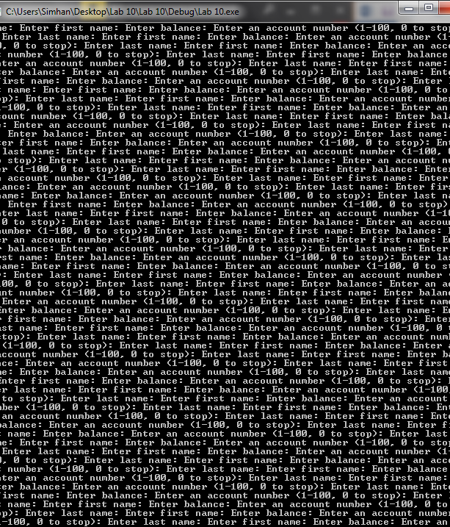

- Error Log
  - Source code might need some fine tuning.

- Status
  - The final status of my program was that it worked but still needs some finer tuning.

